**CosmiCode** **internship**

**Internee Name: Mustafa Ihsan Domain: Cyber Security**

**Week: 2 Network**

**Conduct a detailed network scan using advanced Nmap features:**

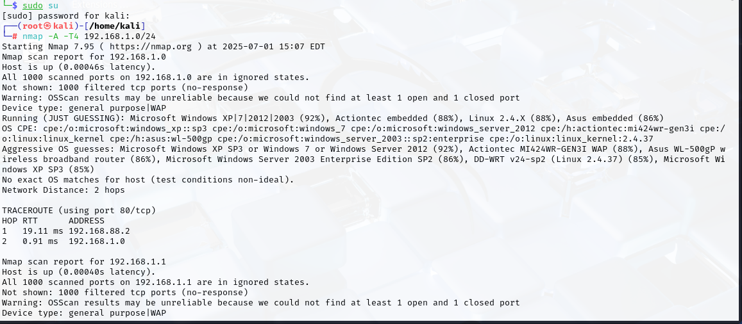

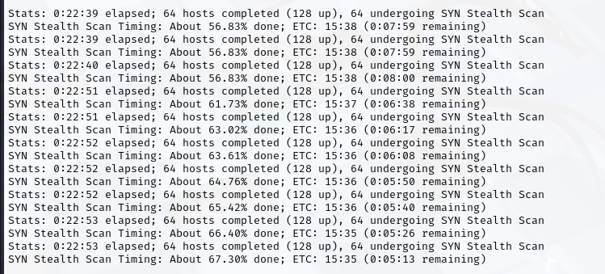

**Use Wireshark to identify and analyze network anomalies:**

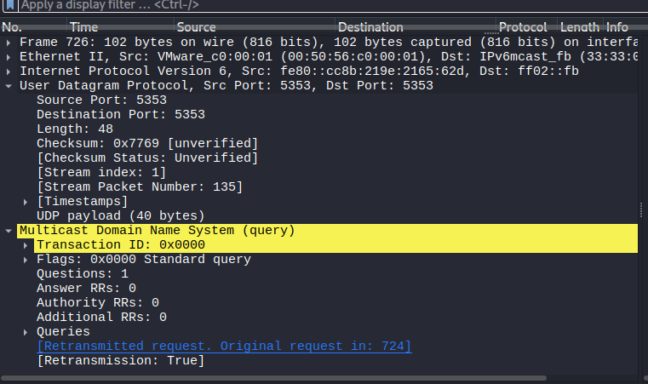

**Configure a basic firewall on a Linux system using iptables:**

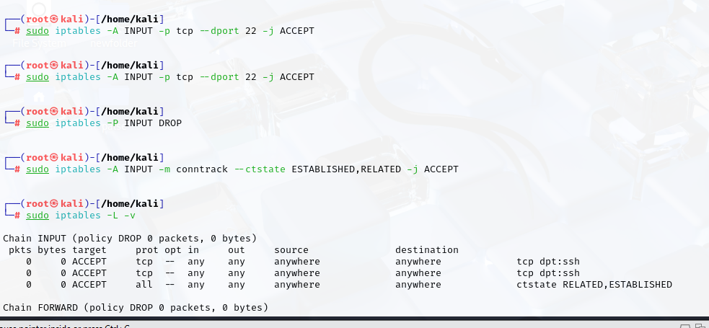

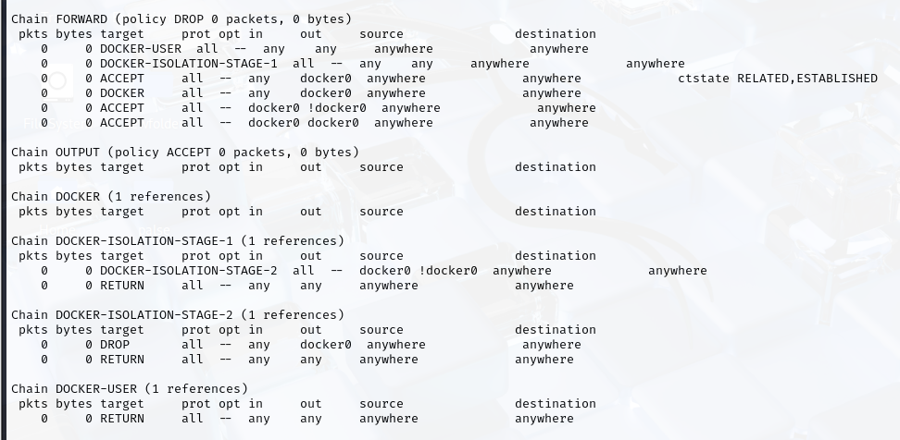

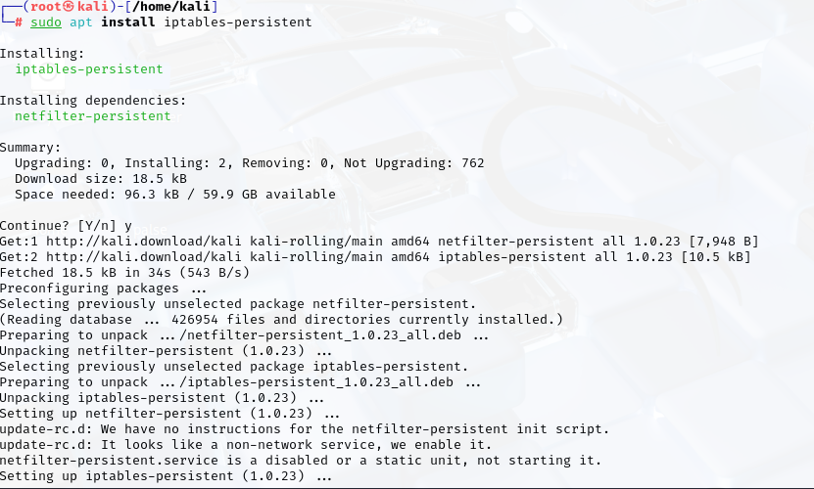

**Set up a simple Virtual Private Network (VPN) and test connectivity:**

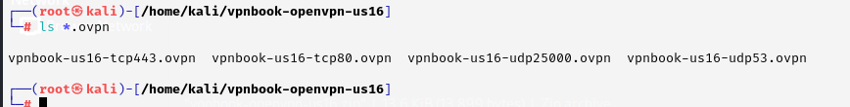

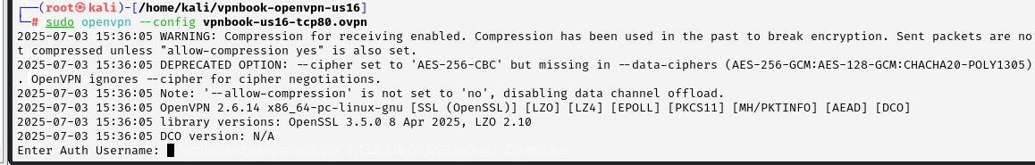

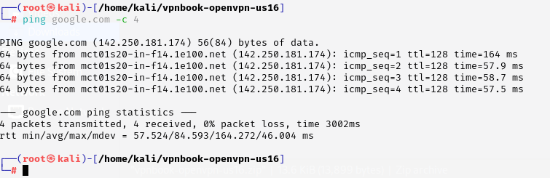

**Implement basic Intrusion Detection System (IDS) rules using Snort:**

